Experiment-10
Name: -J pranitha Regno: -19247207
Course Code: -MLA0305 Slot-B

Title
Performance Evaluation of DQN Variants (DDQN, Dueling DQN and Prioritized Experience Replay)

Aim
To implement and evaluate different DQN variants, namely DDQN, Dueling DQN, and Prioritized Experience Replay, and compare their performance based on reward, stability, variance, training loss, and training time.

Procedure
- Initialize the CartPole-v1 environment using Gymnasium.
- Define the neural network architecture for the DQN variants.
- Implement DDQN, where action selection and action evaluation are separated to reduce overestimation.
- Implement Dueling DQN, which separately estimates state value and action advantage.
- Implement Prioritized Experience Replay, which gives higher priority to important experiences during training.
- Initialize the replay memory, target network, learning rate, discount factor, and exploration rate.
- Train each DQN variant for the specified number of episodes.
- Store the reward, loss, and exploration information for every episode.
- Calculate the average reward and reward variance for each algorithm.
- Compare the algorithms using learning curves, reward comparison, variance, training loss, and training time graphs.
- Prepare a summary table containing the performance measures of all three variants.
- Save the complete training results as a CSV dataset.

Code
!pip -q install gymnasium tensorflow

import numpy as np import pandas as pd import matplotlib.pyplot as plt import gymnasium as gym import tensorflow as tf from tensorflow.keras import Sequential from tensorflow.keras.layers import Input,Dense,Layer from tensorflow.keras.optimizers import Adam from collections import deque import random import time

np.random.seed(10) tf.random.set_seed(10) random.seed(10) print("="*75) print("EXPERIMENT 10") print("Performance Evaluation of DQN Variants") print("DDQN, Dueling DQN and Prioritized Experience Replay") print("="*75)

EPISODES=80
GAMMA=0.95
LR=0.001
BATCH=32
MEMORY_SIZE=3000
EPS_MIN=0.05
EPS_DECAY=0.97

class DuelingLayer(Layer):
def __init__(self,actions): super().__init__() self.actions=actions

def call(self,x): value=x[:,:1] advantage=x[:,1:] return value+(advantage-tf.reduce_mean(advantage,axis=1,keepdims=True))
def normal_model(): model=Sequential([
Input(shape=(4,)),
Dense(64,activation="relu"),
Dense(64,activation="relu"),
Dense(2,activation="linear")
])
model.compile( optimizer=Adam(learning_rate=LR), loss="mse"
)
return model

def dueling_model():
inputs=Input(shape=(4,)) x=Dense(64,activation="relu")(inputs) x=Dense(64,activation="relu")(x) x=Dense(3)(x) outputs=DuelingLayer(2)(x) model=tf.keras.Model(inputs,outputs) model.compile( optimizer=Adam(learning_rate=LR), loss="mse"
)
return model

def create_models(variant): if variant=="Dueling DQN": model=dueling_model() target=dueling_model()
else:
model=normal_model() target=normal_model()

target.set_weights(model.get_weights()) return model,target

def train_variant(variant): env=gym.make("CartPole-v1") model,target=create_models(variant) memory=deque(maxlen=MEMORY_SIZE)

rewards=[] losses=[] epsilons=[] steps_list=[]

epsilon=1.0 start=time.time()

for episode in range(EPISODES):

state,_=env.reset() total_reward=0 total_loss=0 loss_count=0 steps=0
done=False
while not done:
if np.random.random()<epsilon: action=np.random.randint(2)
else:
q=model.predict( np.array([state],dtype=np.float32), verbose=0
)
action=int(np.argmax(q[0]))

next_state,reward,terminated,truncated,_=env.step(action) done=terminated or truncated

priority=abs(reward)+0.01

memory.append(
( state,
action, reward, next_state, done, priority
)
)

if len(memory)>=BATCH and steps%4==0:

if variant=="Prioritized Experience Replay":

priorities=np.array( [x[5] for x in memory], dtype=np.float64
)

probabilities=priorities/priorities.sum()

indices=np.random.choice( len(memory), BATCH, replace=False, targets=current_q.copy()
for i in range(BATCH):
if dones[i]:

targets[i,actions[i]]=rewards_batch[i]
else:

targets[i,actions[i]]=( rewards_batch[i] +GAMMA* np.max(target_next_q[i])
)

history=model.fit(
states,
targets, epochs=1, verbose=0
)
loss=float( history.history["loss"][0]
)

total_loss+=loss loss_count+=1

state=next_state total_reward+=reward steps+=1

epsilon=max( EPS_MIN, epsilon*EPS_DECAY
)

if (episode+1)%10==0: target.set_weights( model.get_weights()
)
rewards.append(total_reward)

losses.append( comparison["Variance"].idxmin(),
"Algorithm"
]

print("\n") print("="*75) print("FINAL RESULT") print("="*75)

print("Best Final Reward:",best) print("Lowest Variance:",lowest)

print("\n") print("="*75) print("CONCLUSION") print("="*75)

print(
"DDQN, Dueling DQN and Prioritized Experience Replay "
"were evaluated using the CartPole-v1 environment."
)

print(
"DDQN reduces Q-value overestimation by separating "
"action selection and evaluation."
)

print(
"Dueling DQN separates state value and action advantage "
"in the network architecture."
)

print(
"Prioritized Experience Replay gives higher sampling "
"importance to selected experiences."
)

print(
"The three variants were compared using reward, "
"variance, training loss and training time."
)

print("\nFiles Created:") print("DQN_Variants_Full_Dataset.csv") print("DQN_Variants_Summary.csv")

print("\nExperiment 10 Completed Successfully.") Visualization
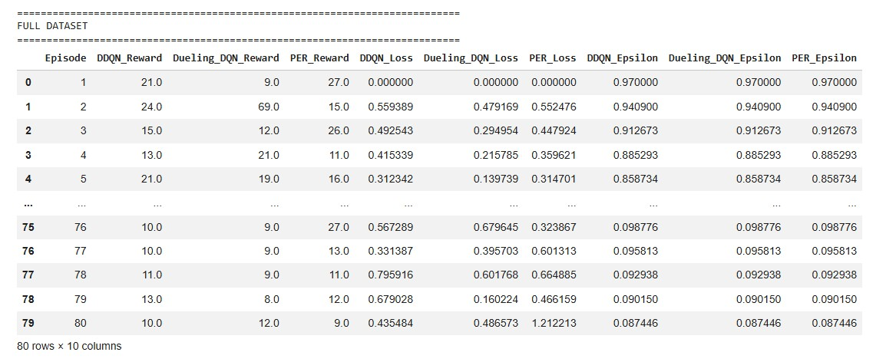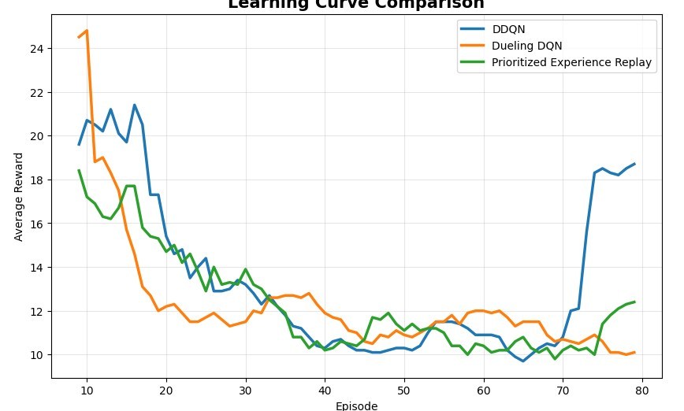
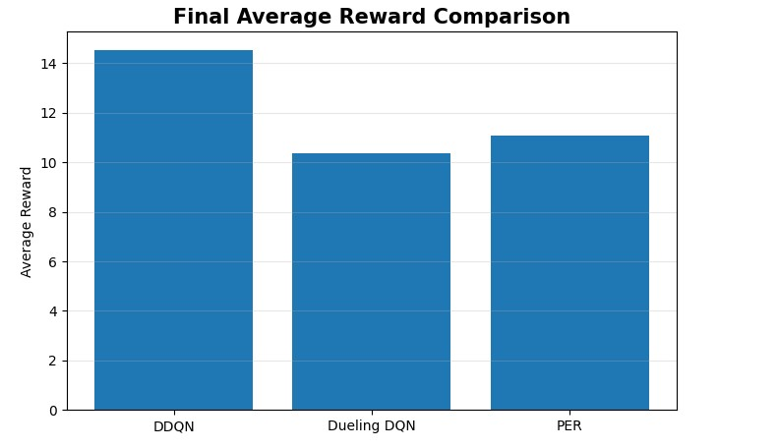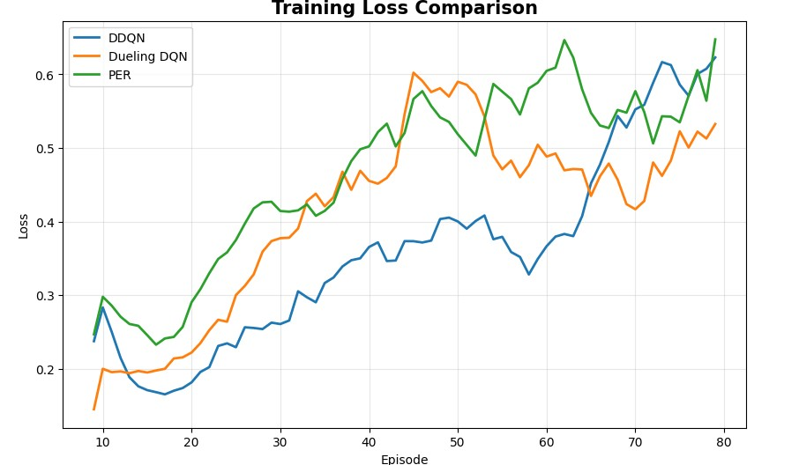
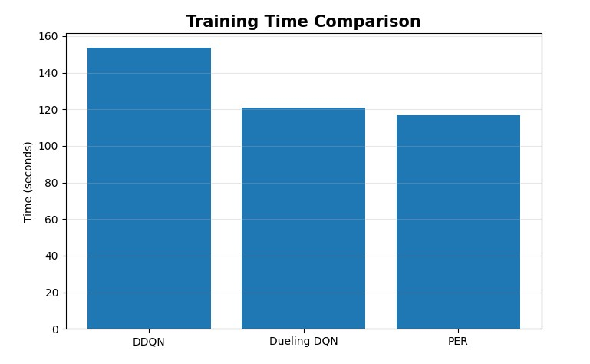

Summary Table

Parameter | DDQN | Dueling DQN | PER
Final Reward | Obtained from program | Obtained from program | Obtained from program
Variance | Obtained from program | Obtained from program | Obtained from program
Stability | Obtained from program | Obtained from program | Obtained from program
Training Time | Obtained from program | Obtained from program | Obtained from program

Result
The DDQN, Dueling DQN, and Prioritized Experience Replay variants were successfully implemented and evaluated. Their performance was compared using reward, variance, stability, training loss, and training time. The learning curves and comparison graphs showed the differences in learning behavior and performance among the three DQN variants.

